**Introduction About Isotopes In Nuclear Technology**

1. **Definition**

Atoms consist of a nucleus and an electron shell; the mass of an atom is concentrated mainly in the nucleus. The nucleus contains nucleons (positively charged protons and neutrons without charge). The much lighter electrons with negative charge “orbit”. around the central nucleus in the electron shell. Electrons and protons are mutually attracted to each other by electromagnetic force.

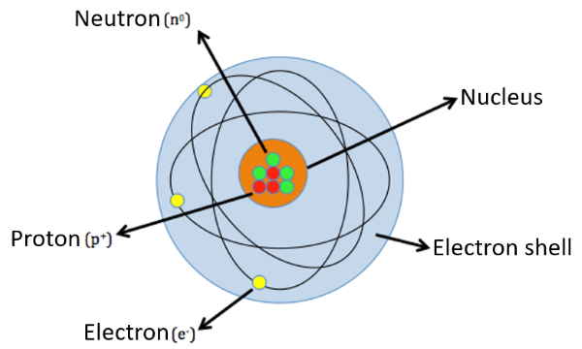

The term nuclide is used to describe atomic species by the composition of the nucleus e.g. by the number of protons (Z) and the number of neutrons (N). Nuclides with the same number of protons are described as isotopes. The term ʻ﻿isotopeʼ was introduced by Nobel laureate Frederick Soddy (1923) through merging the Greek words for ʻequalʼ (ισο—iso) and ʻplaceʼ (τόπος—topos) indicating that all isotopes of the same chemical element share the same position in the periodic table of the elements .

Source: <https://link.springer.com/chapter/10.1007/978-3-030-92698-4_8>

Isotopes are variants of a chemical element whose atoms share the same number of protons (atomic number) but differ in their number of neutrons, and hence in mass number. Although isotopes of an element exhibit nearly identical chemical behavior - because chemical properties are determined by electron configuration —they possess distinct physical properties such as mass and nuclear stability. For instance, carbon-12 has 6 neutrons, while carbon-14 has 8 neutrons.

Source: <https://isotopes.gov/>

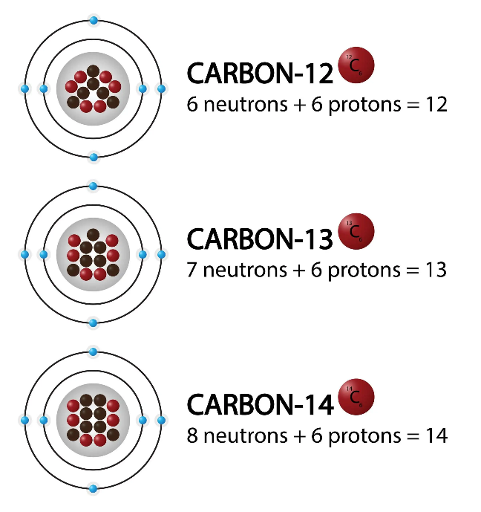

Isotopes are notated in multiple ways. Most commonly, they are specified by the name or symbol of the particular element, immediately following by a hyphen and the mass number (e.g., carbon-14 or C-14). Isotopes can also be defined in standard, or "AZE", notation where A is the mass number, Z is the atomic number, and E is the element symbol. The mass number "A" is indicated with a superscript to the left of the chemical symbol "E" while the atomic number "Z" is indicated with a subscript.

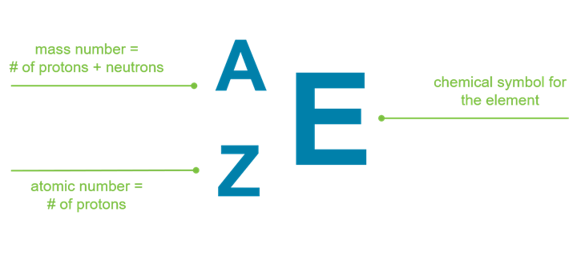

1. **Isotope properties**

Isotopes of the same element have nearly identical chemical properties because they have the same number of protons and electron configuration, but they differ in neutron number, resulting in varied nuclear properties. Some isotopes are called “stable” because their nuclei do not change over time, and most naturally occurring isotopes are stable. Conversely, radioactive isotopes spontaneously decay, transforming into daughter isotopes through decay chains until reaching stability. The decay rate is measured by the half-life, which can range from milliseconds to billions of years (e.g., Uranium-238).

* **Chemical Properties:**
  + Determined by electron arrangement, which is the same for all isotopes of an element.
  + Isotopes form the same types of chemical bonds and generally react similarly in chemical reactions.
  + Slight differences may occur in reaction rates (kinetic isotope effect), especially noticeable for isotopes of hydrogen due to their mass differences.
* **Physical Properties:**
  + Influenced mainly by the difference in mass from varying numbers of neutrons.
  + Variations include differences in atomic/molecular mass, density, melting and boiling points, diffusion rates, and vibrational modes.
  + Nuclear stability varies, giving rise to stable and radioactive isotopes, with distinct behaviors such as radioactive decay in the latter.
* **Nuclear Properties:** Dramatically vary among isotopes, affecting nuclear stability, modes of decay, half-life, and usage in applications like nuclear power and medical imaging.

1. **Isotope Formation and Radiation Types**

Isotopes can either form spontaneously (naturally) through radioactive decay of a nucleus (i.e., emission of energy in the form of alpha particles, beta particles, neutrons, and photons) or artificially by bombarding a stable nucleus with charged particles via accelerators or neutrons in a nuclear reactor. In some cases, a new isotope of the same element is produced. In other cases, an element is converted to another element in a process called "transmutation."

As radioisotopes naturally decay, particles deposit (i.e., lose) energy onto materials such as air, water, and people as it passes through them. Alpha particles energy is deposited across the shortest distance and, therefore, is "stopped" the most easily. Beta particles require slightly more protection, and photons (gamma rays and X rays) need much greater shielding. Neutron radiation is considered the most severe and dangerous to humans due to its high kinetic energy, so it typically requires the most significant shielding. Materials with low atomic numbers (water, carbon, lithium, etc.) that can slow neutrons down usually offer the most effective shielding.

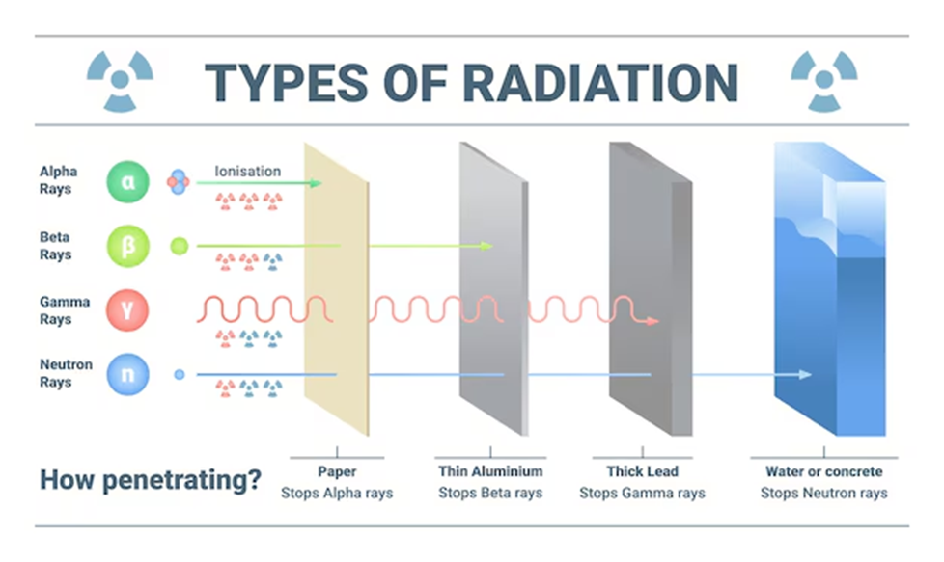

1. **Methods of obtaining isotopes**
   1. **Production in Nuclear Reactors (Neutron Irradiation)**

Stable isotopes or target materials are exposed to intense neutron flux inside a nuclear reactor. Neutron capture reactions turn stable nuclei into radioactive isotopes or produce isotopes by fission. For example, Molybdenum-99 (parent of widely used medical isotope Technetium-99m) is produced by neutron-induced fission of Uranium-235. Neutron activation is widely used because reactors provide a high neutron flux and can produce many isotopes from light (carbon-14) to heavy elements (mercury-203). Target materials are sealed and irradiated in reactor core positions, then chemically processed post-irradiation.

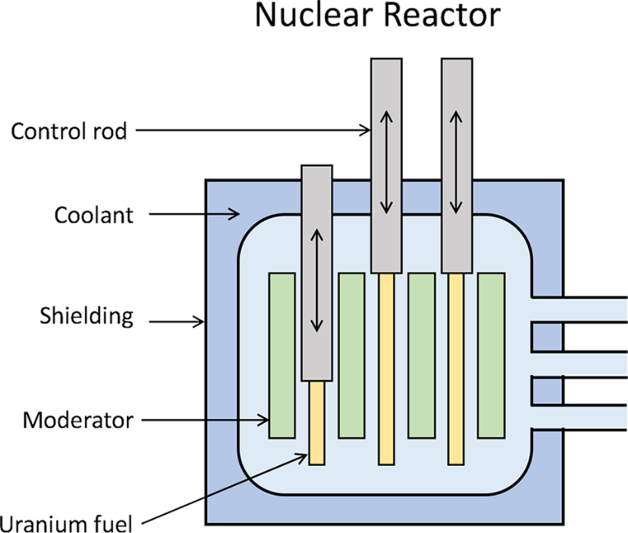

These are step-by-step procedure

**- Neutron Flux and Reactor Environment:** The process begins within a nuclear reactor where a fissile material such as Uranium-235 (U-235) undergoes controlled nuclear fission. This reaction releases a high flux of free neutrons, which possess a broad spectrum of energies. To enhance the probability of neutron capture by target nuclei, these fast neutrons are typically thermalized (slowed to thermal energies) using a moderator such as light water (H2O), heavy water (D2O), or graphite. The resulting thermal neutron flux forms the irradiation environment necessary for inducing nuclear reactions in target materials.

**- Target Material Preparation:** Target materials are selected based on the desired nuclear reaction and resulting isotope. These targets usually contain stable isotopes such as Cobalt-59, Molybdenum-98, or Tellurium-130. The materials are prepared in forms suitable for irradiation (e.g., metal discs, oxides, or pellets) and are then sealed in irradiation capsules or aluminum containers that are chemically and physically compatible with the reactor conditions (e.g., resistant to high temperatures and radiation).

**- Irradiation in Reactor Core:** The prepared targets are inserted into high neutron flux zones either within the reactor core or in dedicated irradiation channels near the core. The placement depends on the desired neutron spectrum and flux intensity. Reactor types commonly used include:

* Light-water swimming pool reactors, which allow easy vertical access for target loading and retrieval.
* Tank-type heavy-water reactors, which use horizontal irradiation channels and higher neutron fluxes.

Irradiation duration is precisely calculated based on the neutron capture cross-section, half-life of the desired product, and required specific activity.

**- Nuclear Reactions During Irradiation.** Several types of nuclear reactions may occur during neutron exposure, including:

*+ Neutron Capture (n,γ) Reaction:* A stable nucleus absorbs a thermal neutron and transitions into a heavier, often radioactive isotope, emitting gamma radiation.

+*Fission Reactions*: In some cases, target isotopes are formed as fission products. For instance, Molybdenum-99 (Mo-99), the parent of Technetium-99m (Tc-99m) used in diagnostic imaging, is produced from the fission of U-235:

Reaction yields depend on several parameters including neutron energy, flux density, and the neutron activation cross-section of the target isotope.

**- Control of irradiation conditions**

To maximize production efficiency and isotopic purity, reactor operators’ control:

* Neutron flux intensity (via reactor power level),
* Irradiation time, and
* Target positioning within the reactor.

Care is taken to avoid over-irradiation, which can lead to saturation activity, production of unwanted byproducts, or target damage. Optimization ensures high specific activity and minimal contamination with isotopic impurities.

**- Removal and Shielding of Irradiated Targets**

After irradiation, the targets are highly radioactive and must be handled using remote manipulators and shielded casks to protect workers from ionizing radiation. Removal procedures follow strict radiological safety protocols to minimize exposure and contamination.

**- Post-Irradiation Processing**

Irradiated targets are transferred to hot cells or radiochemical laboratories for further processing. Here:

* Radiochemical separation is performed to isolate the desired radioisotope from the target material and other reaction byproducts.
* This may involve solvent extraction, ion exchange, or precipitation techniques, depending on the isotope chemistry.

The final product is purified to meet specifications for medical (e.g., radiopharmaceuticals), industrial (e.g., tracers, radiography sources), or research applications. The purity, activity, and form are tailored to end-use requirements.

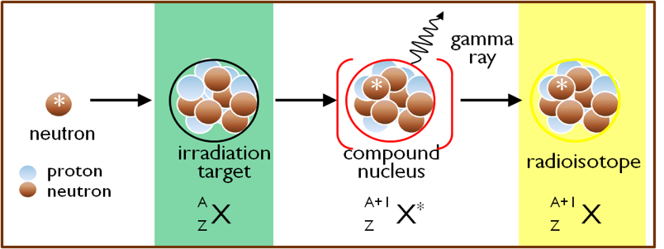

|  |  |
| --- | --- |
| **Advantages** | **Disadvantages** |
| Colomb barrier absence | Large quantities of RW |
| Large volume of irradiation | Isotopic purity of targeted isotope (contamination) |
| Simultaneous irradiation of several samples | Access to reactors is limited |
| Economy of production |  |
| Possibility to produce a wide variety of radiosotopoes |  |

* 1. **Production via Cyclotrons**

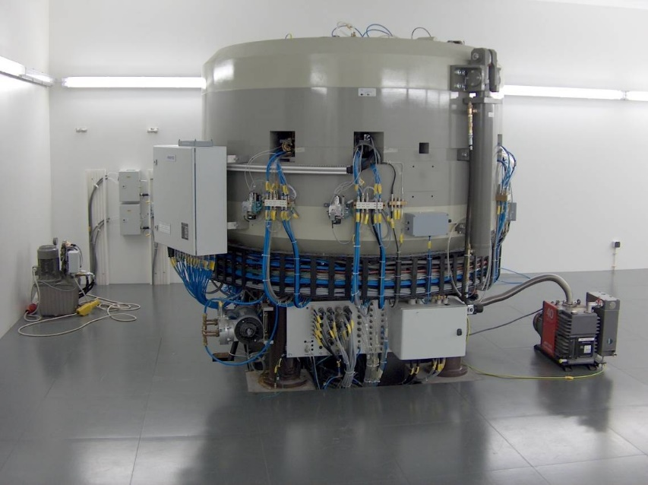

A cyclotron works as a particle accelerator designed to produce isotopes by accelerating charged particles (such as protons, deuterons, or alpha particles) in a spiral path until they reach energies high enough to bombard a target material, causing nuclear reactions that produce radioactive isotopes.

*How a Cyclotron Works*

* Particle Injection: Charged particles, usually protons, are generated in an ion source and injected into the center of the cyclotron’s vacuum chamber.
* Acceleration by Electric Field: Inside the chamber are two hollow, D-shaped electrodes called "dees." A high-frequency alternating voltage is applied between these dees. Each time the particles cross the gap between them, they gain energy, gradually accelerating in small steps.
* Magnetic Field for Circular Motion: A strong, constant magnetic field, applied perpendicular to the particle path, forces the charged particles to move in a circular path. As the particles gain energy, their spiral radius increases, causing them to move outward in a spiral path within the chamber.
* Spiral Path and Energy Gain: Particles continue to spiral outward, crossing the accelerating gap multiple times and gaining energy with each pass.
* Target Interaction: When particles reach sufficient energy near the chamber’s edge, they are directed onto a target material. The high-energy impact induces nuclear reactions that produce radioactive isotopes.
* Isotope Production and Purification: The radioactive isotopes produced are chemically separated and purified from the target material to be prepared for medical or industrial applications.

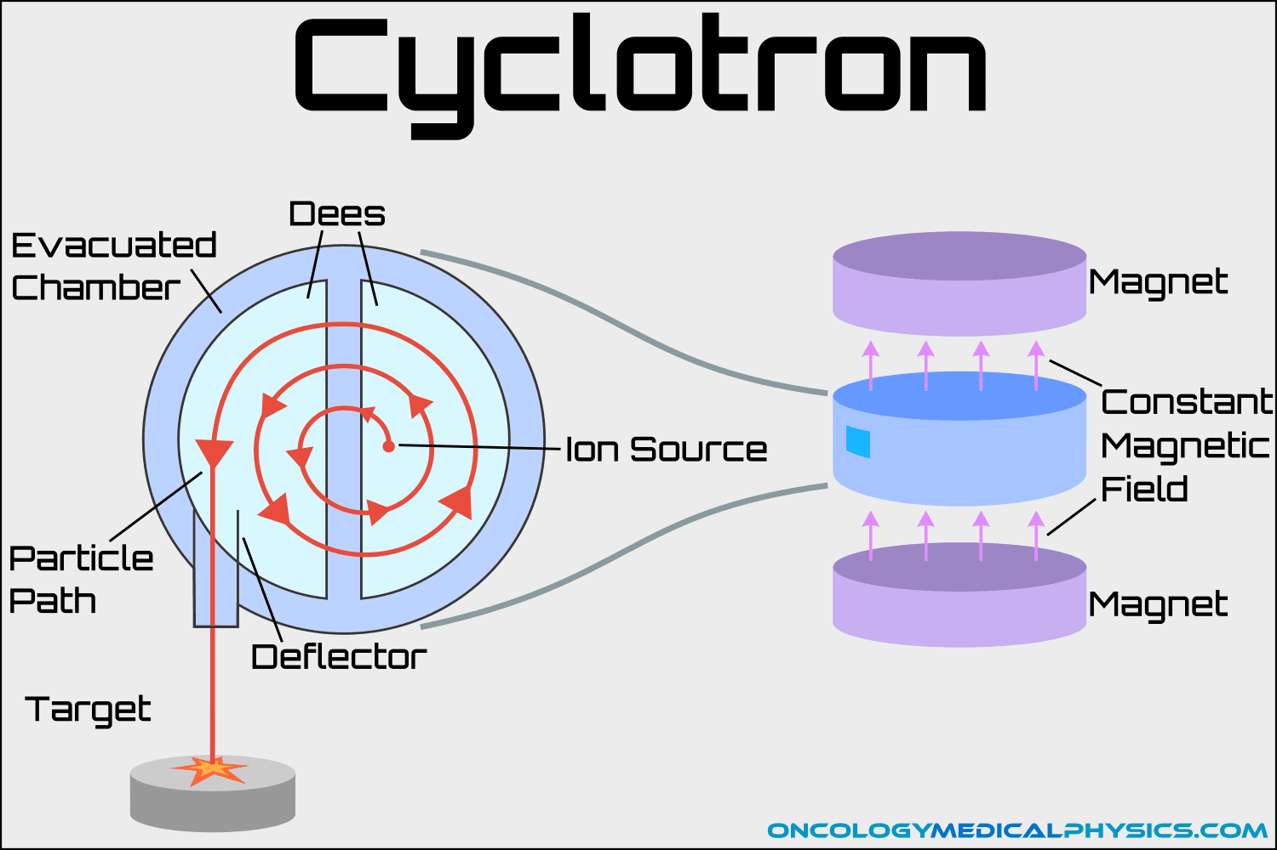

|  |  |
| --- | --- |
| **Advantages** | **Disadvantages** |
| No fission material | A few isotopes at a time |
| Safe, Simple, Reliable | Long time for some isotopes |
| Less RW | Low production rate |
| Can be installed in many hospitals | Repulsion barrier |
| Neutron-deficient isotopes |  |
| Easier isotope isolation |  |
| Short-lived isotopes |  |

## **c. Production via chemical separation**

Chemical methods have been used for more than 60 years to provide significant quantities of separated stable isotopes. Some of the earliest examples include the separation of uranium isotopes by gaseous diffusion, chemical exchange processes to produce C-13 and N-15, and thermal diffusion and distillation to produce O-18, S-34, S-36, and some isotopes of the rare gases.

The general process works as follows:

- First, the irradiated target material containing a mixture of isotopes and target atoms is dissolved or chemically processed.

- Then, separation techniques such as precipitation, solvent extraction, ion-exchange chromatography, or liquid-liquid extraction are applied to isolate the desired radioactive isotope from the bulk target material and impurities.

- Chemical separation is essential not only to purify the isotope for medical, industrial, or research use but also to remove radioactive and chemical contaminants.

While chemical separation cannot easily distinguish isotopes by atomic mass, it improves yield and purity by leveraging differences in chemical behavior caused by isotopic substitution and nuclear transformations

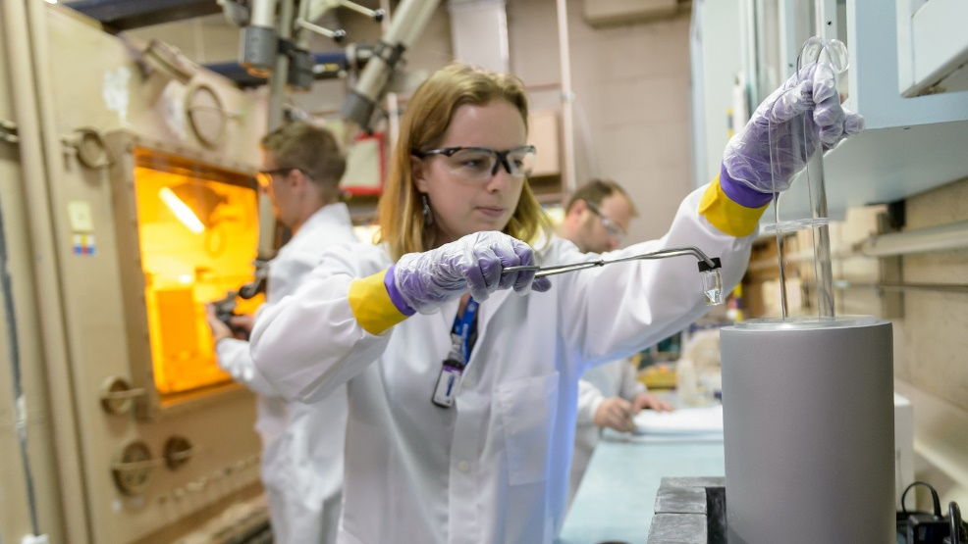

|  |  |
| --- | --- |
| **Advantages** | **Disadvantages** |
| Essential for isolating and purifying specific isotopes from target material. | Sometimes complex and time-consuming chemical processes |
| Can achieve very high chemical purity of end product. | May require handling and disposal of hazardous chemicals. |
| Adaptable to various production methods and isotopes | Efficiency and yield depend on chemical properties; not all isotopes are easily separated. |

## **d. Electromagnetic enrichment and purification**

Electromagnetic separation exploits the mass difference of isotopes to change thƒir deflection in a magnetic field. This low-throughput technique is quite costly but can yield some of the highest purities of separated samples. It is often used in conjunction with other approaches; such as increasing the purity of samples obtained from gaseous diffusion. Devices called calutrons were historically used for electromagnetic purification. This approach can work for almost all elements and is typically used for isotopes of Tl, Pd, Sr, Ca, and the lanthanide series.

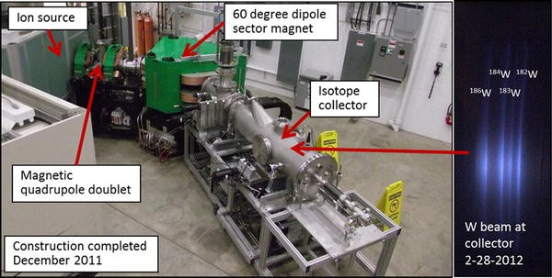

|  |  |
| --- | --- |
| **Advantages** | **Disadvantages** |
| Provides very high isotope purity | High operational costs and low throughput (inefficient for large-scale production). |
| Useful for stable isotopes or where extremely pure samples are needed. | Requires sophisticated equipment such as calutrons. |
|  | Energy intensive and technically demanding. |
|  | Not practical for all isotope types or production scales. |

## **5. Their applications**

### **a. In industry**

Radioisotopes such as Cobalt-60 and Iridium-192 emit gamma rays used to inspect metal parts, welds, and structural components without damaging them. This helps detect cracks, corrosion, or defects in pipelines, machinery, aircraft parts, and construction materials, ensuring safety and quality control.

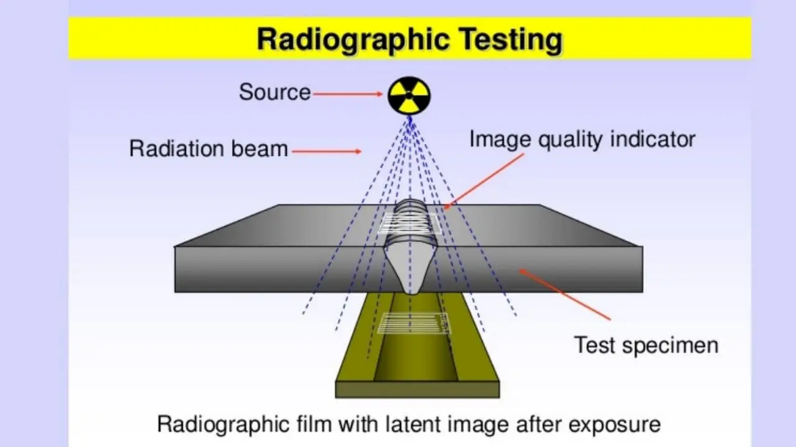

*Monitoring Content of Food*

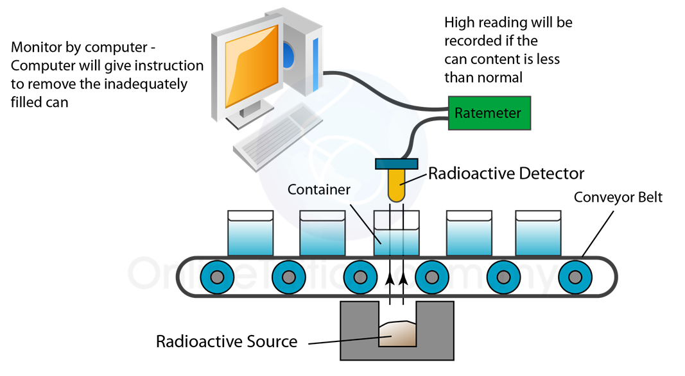

Radioactive isotopes in food give off special rays called gamma rays. Each type of isotope sends out gamma rays with specific energies — like their own unique "fingerprint." A gamma-ray spectrometer is a device that listens to these rays and measures their energy. It sorts the rays by energy and counts how many rays come at each energy level. By looking at this pattern, the device can tell which isotopes are in the food and how much of each is there — all without damaging the sample. This helps check if the food is safe and if any radioactive contamination is present.

*Detecting Underground Leakage*

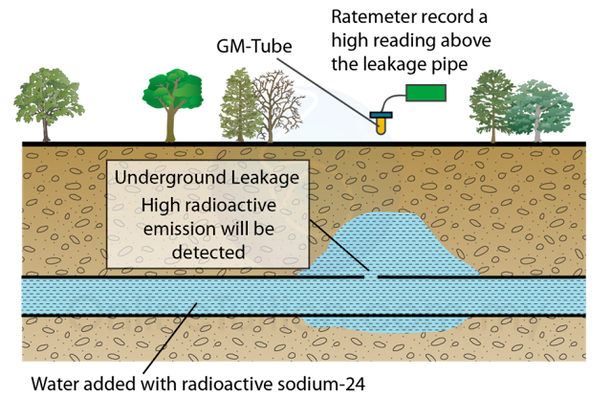

Radioisotope leak detection works by injecting a small amount of a radioactive tracer isotope (commonly emitting beta or gamma radiation, such as Sodium-24 or Bromine-82) into the fluid flowing inside underground pipelines. The radioactive tracer flows through the system, and radiation detectors placed outside, above the pipeline, scan for abnormal radiation signals indicating where the tracer is escaping. This pinpointing helps locate leaks precisely without extensive digging.

*Measuring the Wearing Rate of Engine*

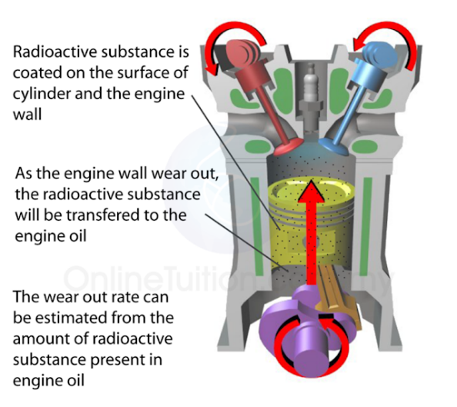

Measuring engine wear using isotopes via Thin Layer Activation (TLA) involves making a thin surface layer of an engine part radioactive by particle irradiation. As the engine runs, tiny radioactive particles wear off into the oil. Sensitive detectors measure this radioactivity in real time, directly indicating wear amount. This method provides highly precise, non-destructive, continuous wear monitoring with sensitivity down to nanometers, commonly used on parts like piston rings, camshafts, and valves.

### **b. In medicine**

Diagnostics

Radioisotopes serve as tracers that emit radiation detectable by imaging devices like PET (Positron Emission Tomography) and SPECT (Single Photon Emission Computed Tomography). These tracers are often attached to molecules that target specific organs or biochemical processes, allowing visualization of physiological functions and detection of diseases such as cancer, heart disorders, and neurological conditions. For example, Technetium-99m is widely used for imaging bones, brain, and other organs, providing high-resolution, 3D images safely and non-invasively. Tracers are administered via injection, ingestion, or inhalation and decay quickly to minimize radiation dose to the patient.

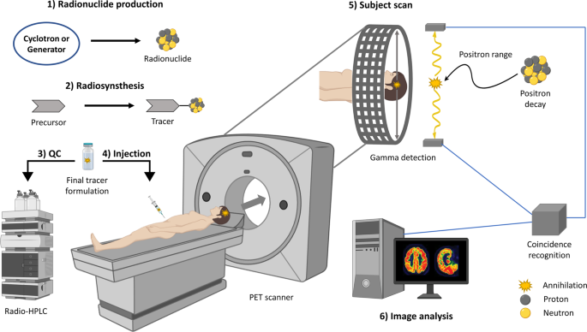

Principle of positron emission tomography (PET) imaging

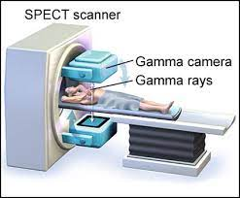

SPECT scan

Gamma Knife

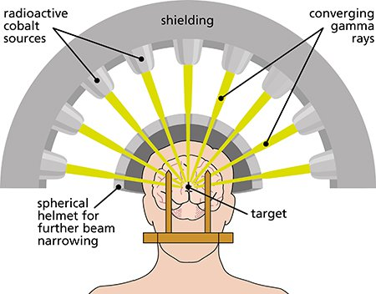

System of Gamma Knife

The Gamma Knife is a non-invasive radiation therapy device that treats brain tumors and abnormalities by focusing about 200 low-intensity gamma ray beams precisely on a small target. The individual beams minimally affect healthy tissue, but where all beams converge, the combined high radiation dose destroys or shrinks the lesion. The patient's head is immobilized, and imaging guides accurate targeting. This method is painless, avoids surgery, and usually completes in a single session with minimal side effects.

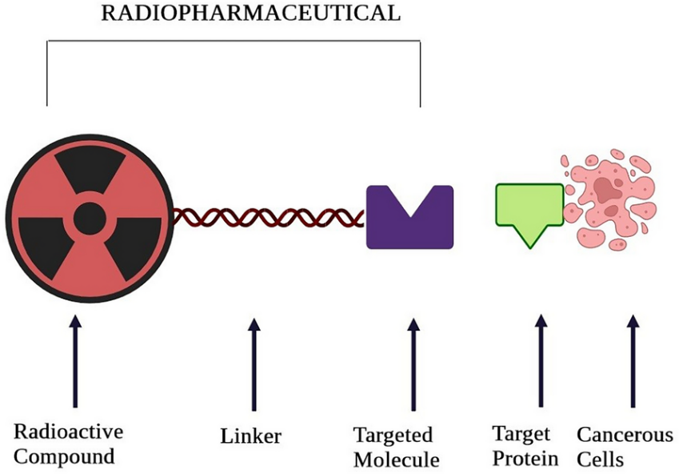

How radiopharmaceuticals work

Radiopharmaceuticals are special medicines that contain radioactive isotopes (radionuclides) combined with molecules that guide them to specific parts of the body. They are given to patients to diagnose diseases by producing images of organs or tissues using emitted radiation, or to treat diseases by delivering targeted radiation that kills diseased cells like tumors.

### **c. In agriculture**

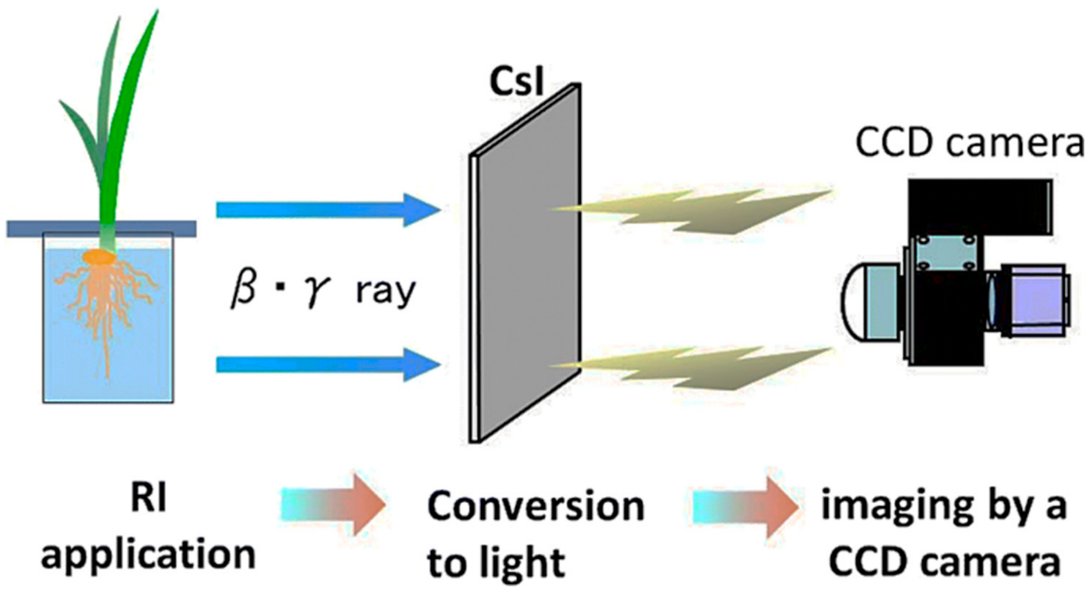

The application of the radioisotopes to the plant

Radioisotopes, especially gamma rays, are used to induce mutations in seeds or plants to develop new crop varieties with better traits such as higher yield, disease resistance, drought tolerance, and improved nutritional value. This radiation-induced mutation breeding has produced thousands of beneficial crop varieties worldwide, including rice, wheat, barley, cotton, and fruit crops.

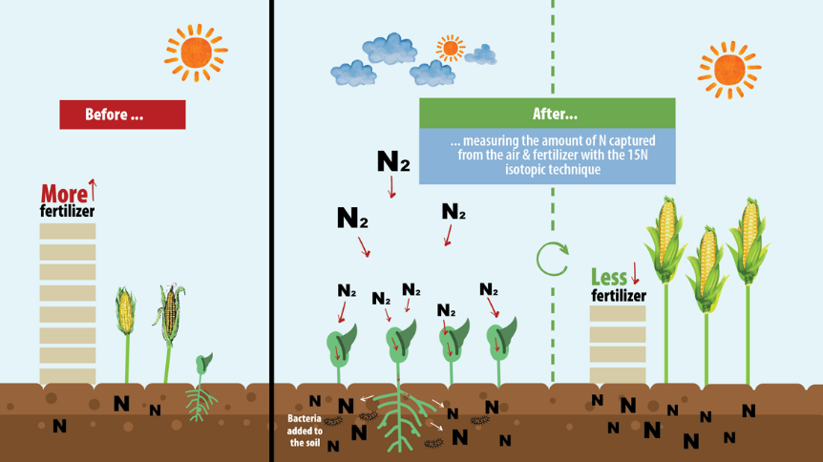

Radioisotope tracers label fertilizers and nutrients to study their uptake and efficiency in plants, enabling optimized fertilizer use to reduce costs and environmental harm. Neutron moisture gauges help measure soil and plant water content, aiding efficient irrigation practices and better water resource management.

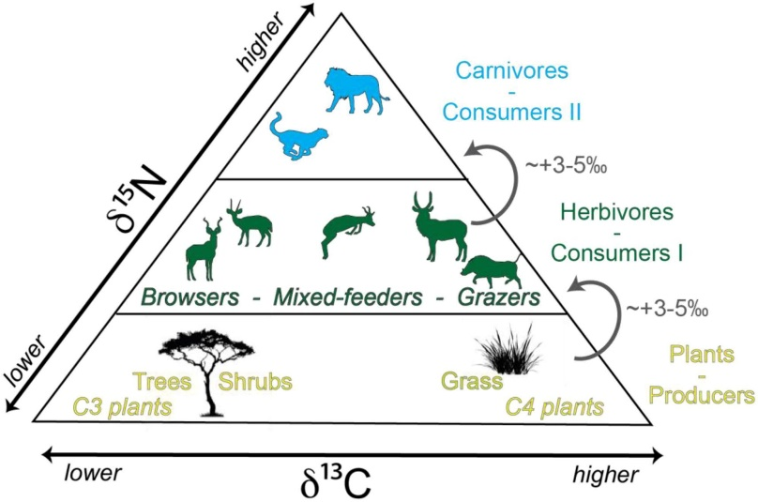

Radioisotope tracers like Carbon-14 help understand the digestion and nutritional value of animal feeds by tracking nutrient absorption in livestock. Radiation techniques have also supported developing vaccines for animal diseases, such as successfully combating rinderpest disease in African cattle populations.

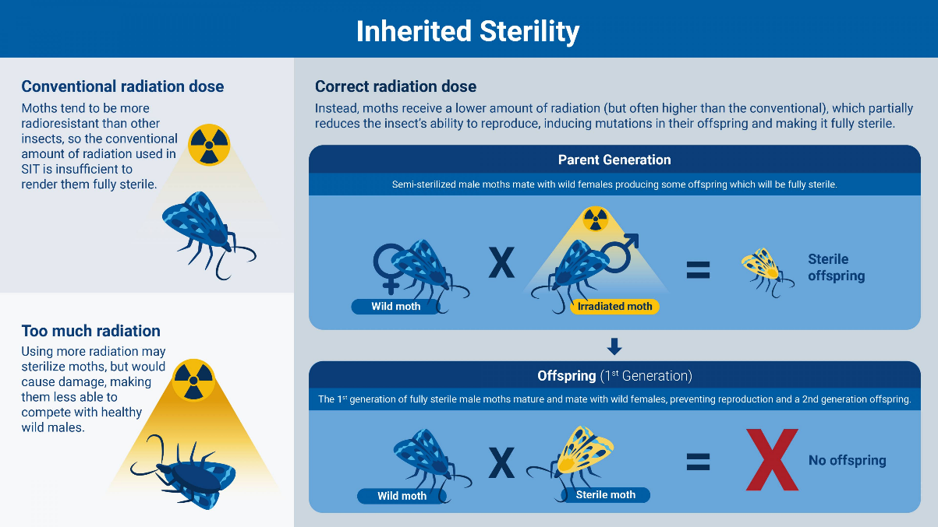

Radiation is applied in sterilization programs like the Sterile Insect Technique (SIT), where male insects are sterilized using radiation and released to reduce pest populations, lowering crop damage without harmful chemicals.

### **d. In space technology**

Radioisotopes in space technology are mainly used as long-lasting power sources through Radioisotope Thermoelectric Generators (RTGs). These devices convert heat from the natural decay of radioactive materials (like plutonium-238) into electricity to power spacecraft, especially when solar power is not feasible—such as in deep space or shaded areas. RTGs provide reliable, maintenance-free energy for decades, enabling missions to distant planets, moons, and harsh environments.

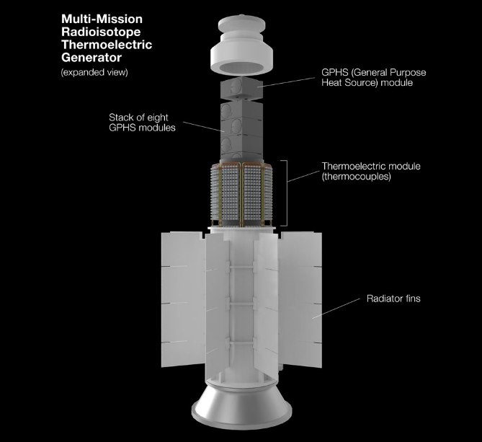

Nuclear reactors and radioisotopes for space

**REFERENCES**

* International Atomic Energy Agency (IAEA). Radioisotopes in Industry. Available at: <https://www.iaea.org/topics/radioisotopes-in-industry>
* World Nuclear Association. Radioisotopes in Medicine. Available at: <https://www.world-nuclear.org/information-library/current-and-future-generation/radioisotopes-production.aspx>
* U.S. Department of Energy (DOE), Office of Isotope R&D and Production. Applications of Isotopes. Available at: <https://isotopes.gov>
* NASA. Radioisotope Power Systems. Available at: <https://rps.nasa.gov>
* FAO/IAEA Agriculture & Biotechnology Laboratory. Applications of Isotopes in Agriculture. Available at: <https://www.iaea.org/topics/agriculture>
* European Nuclear Society. Radioisotopes in Medicine. Available at: <https://www.euronuclear.org/info/encyclopedia/r/radioisotopes-in-medicine.htm>
* TRIUMF. Cyclotron and Isotope Production. Available at: <https://www.triumf.ca>
* ResearchGate. Various research papers on isotope production and applications. Available at: <https://www.researchgate.net>